**Lead: Dr. White Ryan Research Lab: NETS  
Research Assistant: Lamine Deen**

**Combining PEEK Maps with Mutual Information (MI) and Paired-Pixel Mutual Information (PPMI)**

Analyzing and optimizing convolutional neural networks (CNNs) often requires detailed insights into their internal behavior. Combining PEEK maps with Mutual Information (MI) and Paired-Pixel Mutual Information (PPMI) introduces a synergistic methodology that enhances our ability to understand and improve CNNs. Below is an overview of this integrated approach.

**Conceptual Integration**

**PEEK Maps**

PEEK maps are entropy-based visualizations that highlight regions of uncertainty and focus within CNNs. By identifying areas of high entropy, PEEK maps indicate where the model struggles to make confident predictions. These visualizations are instrumental in pinpointing challenging regions in the input data where the network's attention or understanding may be insufficient. This information is critical for refining network design and improving decision-making processes.

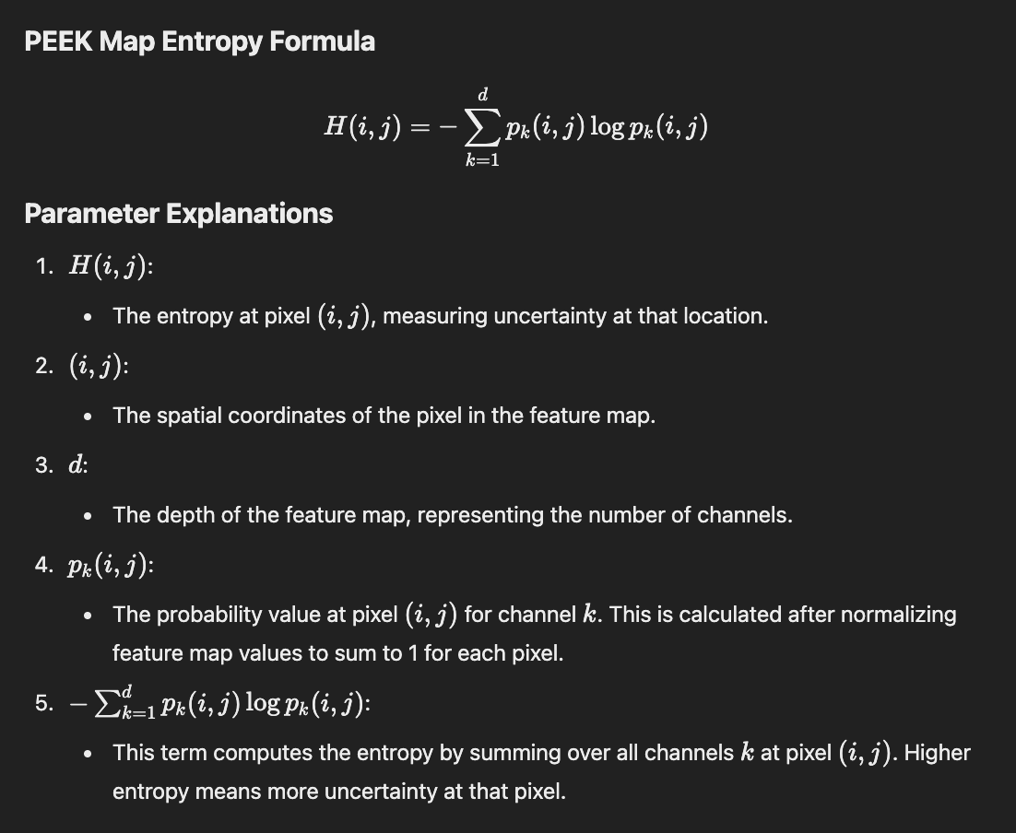

**Mutual Information (MI)**

Mutual Information quantifies the dependency and shared information between different variables or features within the network. It measures how much knowing one feature reduces uncertainty about another, offering insights into how information flows between layers or feature maps. This technique is especially useful for understanding the redundancy and relevance of features within the network, helping to streamline its operation.

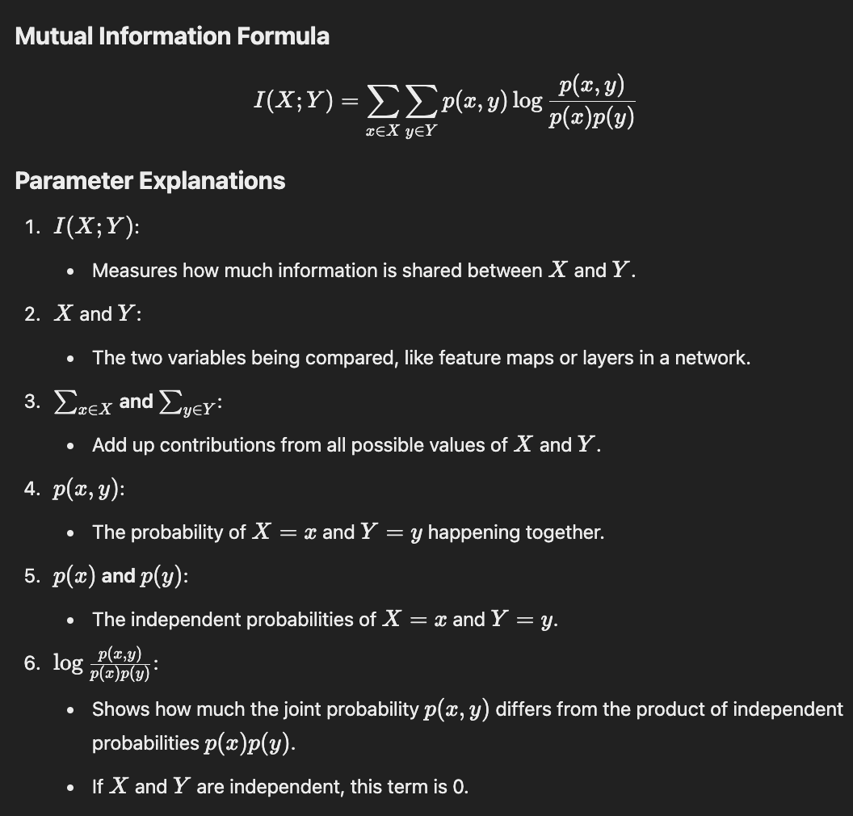

**Paired-Pixel Mutual Information (PPMI)**

Paired-Pixel Mutual Information extends MI by analyzing the relationships between pairs of pixels across feature maps. This provides a granular view of spatial and feature interactions, contributing to a deeper understanding of how the network processes and interprets input data. By focusing on pixel-level dependencies, PPMI uncovers subtle patterns that are often missed by broader analysis methods.

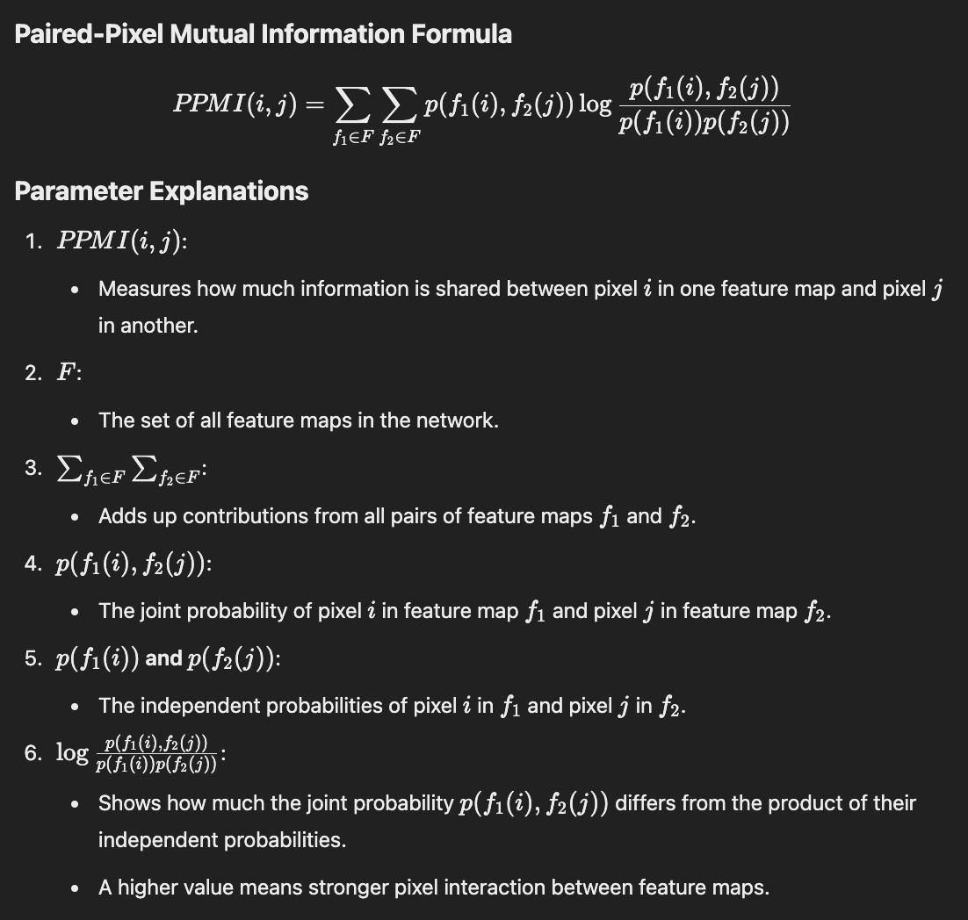

**Shared Purpose**

The combination of PEEK maps, MI, and PPMI aims to analyze, visualize, and optimize the internal workings of CNNs:

- PEEK Maps focus on uncertainty and saliency, identifying regions where the network struggles.

- MI and PPMI focus on feature dependencies and interactions, uncovering the reasons behind the observed uncertainty.

Together, these methods provide complementary perspectives. PEEK maps identify "where" the network encounters challenges, while MI and PPMI explain "why" those challenges occur by revealing the dependency and interaction patterns within the network. This dual approach allows for a more targeted and efficient optimization process, bridging the gap between high-level visualization and detailed dependency analysis.

**Methodology for Combining PEEK, MI, and PPMI**

**1. Entropy-Driven Analysis (PEEK)**

- Generate PEEK maps to identify regions of high entropy in feature maps.

- Overlay these maps on input images to visualize areas where the CNN focuses or expresses uncertainty.

- Use these visualizations as diagnostic tools to understand the areas requiring additional refinement or training data.

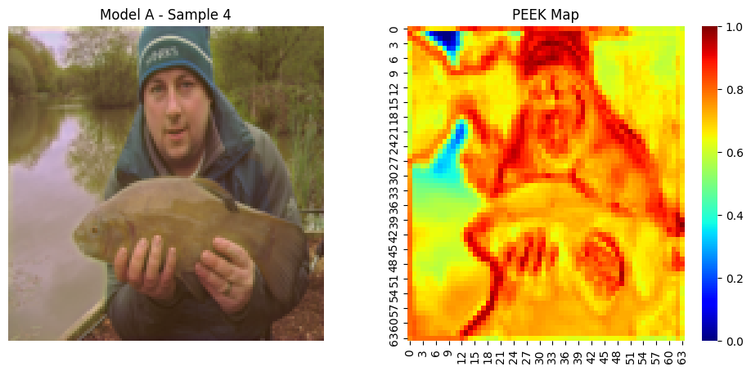

**2. Mutual Information Analysis (MI)**

- Calculate MI between high-entropy feature maps and their neighbors.

- Use MI to uncover dependency patterns and redundant or underutilized features contributing to uncertainty.

- Employ MI results to streamline feature interactions, reducing noise and improving focus within the network.

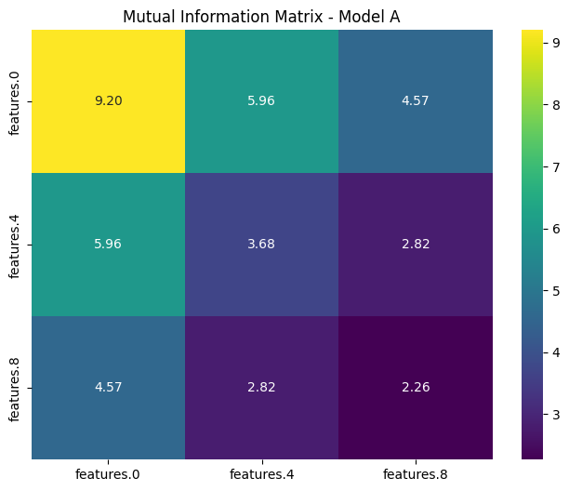

**3. Granular Dependency Analysis (PPMI)**

- Examine pixel-level relationships in high-entropy regions identified by PEEK maps using PPMI.

- Detect inconsistent or weak feature interactions that may be causing uncertainty.

- Utilize PPMI insights to refine spatial coherence and optimize pixel-level dependencies for better generalization.

**4. Iterative Optimization**

- Use PEEK Maps to identify high-entropy areas requiring improvement.

- Leverage MI and PPMI to optimize the network by:

- Encouraging complementary MI patterns across feature maps.

- Regularizing pixel-level interactions based on PPMI insights.

- Revising architectural elements such as receptive fields and attention mechanisms.

- Implement entropy-based loss terms to penalize uncertain predictions and improve spatial coherence.

**Example Application: Optimizing a CNN for Object Detection**

Step 1: Generate PEEK Maps

Step 2: Apply MI Analysis

Step 3: Analyze High-Entropy Areas with PPMI

Step 4: Guide Architecture Design

Adjust the CNN architecture based on MI and PPMI insights. For example:

- Add attention mechanisms to improve focus on important regions.

- Modify receptive fields to capture more relevant spatial patterns.

- Implement entropy-based loss terms to improve predictions in uncertain regions.

- Use these insights to fine-tune hyperparameters and optimize training strategies, resulting in a more robust and efficient model.

**Key Benefits of the Combined Approach**

**1. Enhanced Interpretability**

- PEEK maps visually explain uncertainty by highlighting problematic regions.

- MI and PPMI reveal the underlying dependencies and feature interactions causing uncertainty.

**2. Focused Optimization**

- High-entropy regions identified by PEEK maps guide MI and PPMI analysis, leading to targeted architectural or training improvements.

**3. Robust Model Design**

- Combining entropy regularization (PEEK) with feature dependency analysis (MI and PPMI) produces models that are both more interpretable and higher performing.

**4. Versatility**

- This approach applies to a wide range of tasks, from static image analysis to dynamic video processing, making it broadly useful in CNN optimization.

- Its adaptability ensures it can be integrated into various domains, including medical imaging, autonomous vehicles, and more.

**Conclusion**

By integrating uncertainty visualization (PEEK maps) with dependency analysis (MI and PPMI), this methodology provides a comprehensive framework for diagnosing, interpreting, and optimizing CNNs. The synergy between these techniques enables a deeper understanding of model behavior, leading to improved performance and robustness. This combined approach not only enhances the interpretability of CNNs but also paves the way for developing more efficient and reliable models, ensuring their applicability in a wide array of practical use cases.